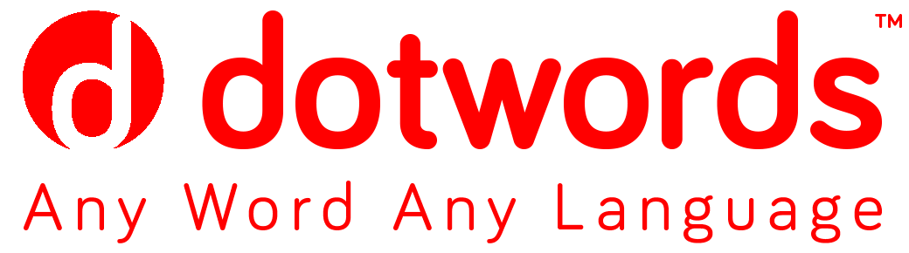

COMPANY Information

• Company profile Page 2
• Partner for international expansion Page 5
• Management Page 7
• Scenario Page 9

Dotwords on the web:
http://www.dotwords.it/blog/
https://twitter.com/godotwords
https://www.facebook.com/pages/Dotwords/753168618101483?fref=nf
For more information
Gabriella Soldadino
Gabriella.soldadino@dotwords.it
Tel. (+39) 02367233 20
Cell. (+39) 347220421

COMPANY PROFILE
AN INNOVATIVE  START-UP | Dotwords is an innovative start-up, which began operations in February 2015. It develops cloud-based IT solutions for the management of translations and localizations to and from any language: These solutions form the DTMS – Dotwords Translation Management System.  Dotwords successfully completed the certification process for the compliance of its language services with the new UNI EN ISO 17100:2015 standardand for the compliance of its quality management system with the ISO 9001:2015 standard. We are one of the first LSP start-ups to obtain both of these important endorsements.  The company was conceived by and leverages the international managerial experience in the language sector of Gabriella Soldadino, who is convinced that Italy’s language service providers (LSPs) are tied to traditional methods, while the technology used in North America and northern Europe has brought enormous benefits in language services: innovations combining top service quality with significant cost efficiencies.  Dotwords was established in November 2014. A month later, it was recognized as an “innovative start-up” by the Milan Chamber of Commerce.
A model of  OPEN INNOVATION | The distinguishing feature of Dotwords, which generates unique value for businesses targeting global growth, is its business model based on Open Innovation, the core of the agency’s philosophy: a knowledge management model that shares tools and competences with clients and partners. On its market, Dotwords is the only LSP in Italy to make its cutting-edge technology and personalized databases (memories, glossaries and dictionaries) available to the organizations with which it works. Through this open process, Dotwords guarantees maximum cost effectiveness and translations of the highest quality.
ITALIAN ROOTS,  INTERNATIONAL OFFICES:  a revolutionary video service with a US patent | Dotwords has a strategic partnership with Dotsub, a US company with offices in Canada and Argentina, and is the sole licensee in Italy and the preferential partner for Europe of the Dotsub patented latest-generation web-based technology. The technology enables videos to be captioned and translated, simultaneously, into hundreds of languages, generating significant advantages over traditional methods:  - Shorter translation times  - 5/10-fold cost reductions  - Automatic indexing on the main search engines.
INTERNATIONAL GROWTH | Dotwords addresses businesses and organizations operating on the multilingual competitive markets created by globalization, as well as local companies targeting international expansion, with a full set of services supporting international expansion, development or consolidation.  Language is the first link connecting businesses to the markets on which they operate; moreover, respect for linguistic diversity is a fundamental component of innovative CSR policies in today’s global age.  In this connection, Dotwords has a strategic partnership with Amapola, an Italian consultancy active in sustainability and internationalization services, which specializes in relationship management (media, government and local communities), content production and the development of digital and multimedia tools.  The key objective of the partnership is to combine the two companies’ respective areas of expertise for a full range of international growth support services and the development of innovative solutions.
A “visionary” young female company | The chief executive officer is Gabriella Soldadino, who was a partner and worked with some of Italy’s most important LSPs before creating Dotwords.  The other two founder partners are Cristina Franco, who brings her academic and relationship management experience, and David Orban, who contributes his visionary passion for technology and multilingualism: two thirds of the company’s equity is held by the female partners.  Dotwords is headquartered in Milan and plans to recruit from 5 to 10 new specialists (web specialists, project managers, sales specialists) during its first two years of operation.

Some customers ABBOTT DIAGNOSTICS, ACQUA MINERALE SAN BENEDETTO, AON, ARVAL COSMETICS, ASSICURAZIONI GENERALI, ATLAS COPCO, B.BRAUN, BANCA MEDIOLANUM, BECKMAN COULTER, BITNATION, BLUE SKY COMMUNICATION, BOBST, BOLTON GROUP, BRACCO, BURBERRY, BUREAU VERITAS, CALVI, CEGOS, CELLULAR LINE, CITYLIFE, COCCINELLE, CLAPIS PRODUCTION, CLAY PAKY, COLLATERAL FILM, COMAU - Gruppo FCA, COMER INDUSTRIES, CTM TERMOTECO, CONTINUUS PROPERZI, COTRIL, DPS ONLINE, DUCATI, EF EDUCATION FIRST, ENGIE, FRANCO MARIA RICCI EDITORE, FINCIBEC, HOGAN LOVELLS, HUAWEI, INNOCEAN WORLDWIDE, ISTITUTO GANASSINI, GENERALI, GIO’ STYLE, GLOBAL STUDIO TCA, IMMSI, ITALCEMENTI, ITALMOBILIARE, LVMH, MONDADORI, MARCO MONTEMAGNO, MAS PACK PACKAGING, MEDACTA, MOMO DESIGN, NEOPOST, NORDSON ITALIA, NTT DATA, OFFICINE BIGLIA, PANDORA, PANOTEC, PARADOX, PIAGGIO, PRELIOS, PRISMALUX, PWC, R.T.I. Reti Televisive Italiane, ROTOLITO, SAMSONITE, SANOFI, SAS, SAET, SDL TRADOS, SENSITRON, SIREG, STERIVALVES, TECHINT, TECHNOGYM, TENOVA, TORNOS SA, TRELLEBORG, UFLEET, UNICEF, UNIVERSITA’ DEGLI STUDI DI MILANO, UNILEVER, UTILITALIA, VECTOR AEROSPACE, VOLVO PENTA, WIKO MOBILE.

A SINGLE PARTNER FOR THE INTERNATIONAL GROWTH OF ITALY’S CORPORATIONS AND SMEs
DTMS PLATFORM  - Technology  - Sharing  - Speed  - Efficiency  - Localization | Dotwords manages the entire translation workflow through its web platform, the Dotwords Translation Management System (DTMS), which provides clients with a personalized area in the cloud where they can store projects, memories and requests, and guarantees interaction at every stage of the project – analysis of objectives, budgeting, workflow planning, sharing of the results of translation, copywriting, dtp and web activities – to guarantee additional cost savings on subsequent projects.  Dotwords uses the skills of a worldwide network of more than 5,000 translators and localizers, including a number of native-speaker SEO copywriters, who deliver persuasive copy optimized for search engines in the original languages of the target market.  The DTMS approach permits significant cost savings and shorter translation times, to attract user segments currently put off by the management complexities and costs of the solutions offered by the market.  CAT technology enables translators to create translation memories from previously translated texts, and organize them into terminology databases with various access levels. The DTMS incorporates a series of software applications such as InDesign, QuarkXPress, PowerPoint, allowing translators to overwrite text directly on the web or in the original format, thereby avoiding the need for text editors.  The benefits of the Dotwords solution drive a process of “cultural growth” among corporate clients as they realize the advantages of an open, transparent and comprehensive technological approach to language services. Here, Dotwords services raise the awareness of Italian companies, including SMEs focused on exports.
DOTSUB CAPTIONING | Dotwords intends to take full advantage of the explosion in online videos, which will account for more than 90% of Internet traffic by the end of 2017 (source Cisco Visual Networking Index).  Dotwords is the exclusive licensee in Italy and the preferential partner for Europe of the brand new web-based technology patented by Dotsub (a US software house), used to caption and translate videos into 520 languages with significant cost and time savings, so that video “spoken” content can be indexed for unprecedented visibility:  - Search engine optimization (SEO) for videos too. Videos only “speak” when they have a listener. With captions, the “spoken” content can be indexed by search engines and located by everyone.  - Effective communication. Captions in the same language as the spoken content increase a video’s addressable audience by 20 to 30% (source Dotsub survey).  - Overcoming barriers. Same-language captions ensure understanding in non-audio contexts (e.g., on smartphones), and among special audiences such as the hearing-impaired.  - Greater interaction. Videos with translated captions generate greater interaction and response. In the USA, Dotsub estimates that the engagement level of Hispanic audiences rises by 200% when videos have Spanish captions.  - Longer viewing time. Viewers spend 35% more time watching captioned videos than uncaptioned material (source Dotsub survey).  - Enhanced video lifetime. Videos with translated captions have far greater lifetime value on the net.
DOTWORDS SERVICES  OVERVIEW | TRANSLATION – INTERPRETING – TRANSCREATION (“creative translation”, a specialized localization activity for journalistic, promotional and advertising material and documents with a high creativity content) – WEB LOCALIZATION AND SEO – COPYWRITING AND TECHNICAL WRITING – DESKTOP PUBLISHING – SOFTWARE AND MULTIMEDIA LOCALIZATION – EDITING AND PROOFREADING – VIDEO CAPTIONING AND LOCALIZATION – INTERNATIONALIZATION SUPPORT

MANAGEMENT

Gabriella Soldadino  Dotwords Founder, Chief Executive Officer  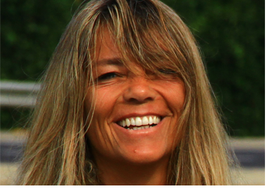 | Gabriella Soldadino has worked in the Language Services Provider field for many years, developing a unique understanding of the business.  After graduating in Foreign Languages & Literature from the International University of Languages and Media (IULM) in Milan, she lived in France and South America to perfect her language skills.  Gabriella began her career working as a teacher. A growing interest in translation, and in translation project development in particular, led her to join Logos, at the time Italy’s largest LSP. She held a number of posts at Logos before becoming a partner and subsequently CEO of Logos’ Milan branch.  In the mid-1990s, Gabriella left Logos to move to Soget, where she was a prime contributor to the new company’s rapid growth. Gabriella focused on new business development, becoming Soget’s commercial manager and later a partner in the firm. In the eighteen years under her commercial and entrepreneurial lead, Soget built up impressive market share, developing ties with many international companies and positioning itself as Italy’s second-largest LSP.  Gabriella left Soget in 2012. In 2014, with David Orban and Cristina Franco, she developed the business model for Dotwords, an international operator active in the development of the translation culture in a scenario of continuous technological innovation.  Gabriella’s family lives in Milan and Berlin. She has many interests, not only in the language field but also in asthanga yoga, reading and travel, and issues relating to the global South.
David Orban  Dotwords Founder, Technical Development Leader  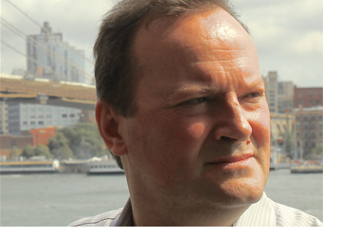 | Entrepreneur David Orban is the CEO of Dotsub, the leading technology and services provider powering video viewing via captions, based in New York City.  David was named as one of the four Ambassadors of the Globalization and Localization Association (GALA) for the two years 2015-2016.  He has been made an Advisor by the Singularity University, where he is a faculty member, in recognition of his contribution to raising understanding of exponentially advancing technologies.  David was Chair of the Board of Humanity+, an organization dedicated to promoting understanding, interest, and participation in fields of emerging innovation. H+ is a growing movement of people working proactively to improve the human condition through commitment to scientific progress.  He was also one of the founders and chief evangelists of WideTag, Inc., a hi-tech start-up active in the development of an infrastructure for the Internet of Things.  David is co-founder of Startupbusiness, a social network aimed at enabling the Italian start-up ecosystem. Startupbusiness is a spin-off of Questar, an Italian software distribution company founded by David. Questar’s mission is to strengthen electronic software distribution services, making them available to developers all over the world.  He is also a scientific advisory board member for the Lifeboat Foundation, a non-profit dedicated to encouraging scientific advancements while helping humanity survive existential risks. The foundation develops mechanisms to discourage abuse of increasingly powerful technologies such as nanotechnology and artificial intelligence.  David is also a founder of the Open Government Data working group, which promotes a more robust understanding of why open access to government data is essential to democracy. The group uses civic debate as a tool to make government a more effective and transparent part of our lives.  His educational background includes studies in Physics at both the University of Milan and the University of Padua. Born in Budapest, David works in the USA and Italy, where he and his family live.

SCENARIO

1) THE WORLD’S LANGUAGES: 90% OF THE WORLD POPULATION DOES NOT SPEAK ENGLISH
- There are 6,700 languages in the world: Mandarin Chinese is spoken by 12.44% of the world population, Spanish and English by 4.8%
- Global internet usage: 75% outside the USA
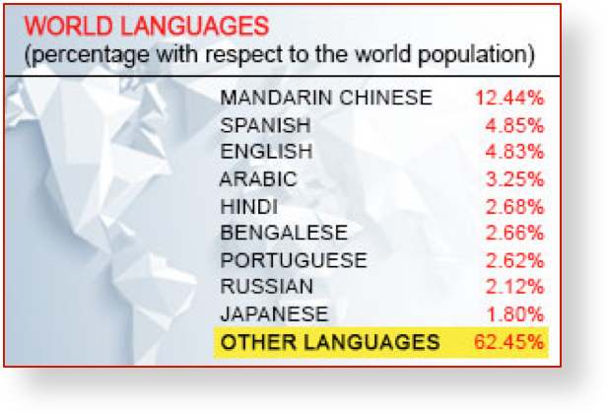
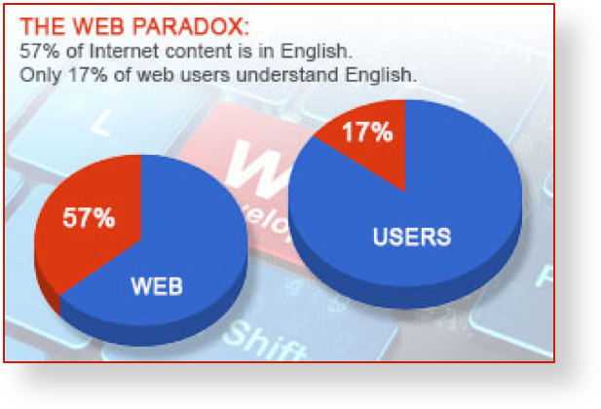
2) THE ONLINE VIDEO EXPLOSION
- Today: 72 hours of video uploaded to YouTube every minute (SOURCE?)
- December 2020: video accounts for 90% of Internet traffic (source Cisco Visual Networking Index)
- The spoken content of videos cannot be indexed

